**ASSIGNMENT # 03**

**CUI Cafe Management System**

**SP24-BSE-020**

**FA23-BSE-039**

**SP24-BSE-100**

**CUI Cafe Management System**

**Overview**

The CUI Cafe Management System is a JavaFX-based application designed to facilitate the management of a cafe. It allows students, faculty, and staff to place orders, view menus, and submit reviews. The system consists of a server that handles requests from multiple clients (students and faculty) and an admin interface for managing orders and menu items. The application uses two text files for data storage: one for the cafe menu and another for customer reviews.

**Key Components**

1. **Server**: Manages connections from multiple clients, processes orders, and sends bills.
2. **Client Applications**:
   * **StudentClient**: Allows students to view the menu, place orders, and submit reviews.
   * **FacultyClient**: Similar to StudentClient but tailored for faculty members.
   * **AdminClient**: Provides an interface for administrators to view orders and generate bills.
3. **Data Storage**:
   * **cafemenu.txt**: Contains the menu items, their quantities, and prices.
   * **CafeReviews.txt**: Stores customer reviews, including designation, name, comments, and ratings.

**Important Methods**

* **CuiCafe**: The main application class that sets up the user interface and navigation.
* **CafeReviews**: Handles the display and filtering of reviews.
* **AdminClient**: Connects to the server, retrieves orders, and generates bills.
* **StudentClient** and **FacultyClient**: Connect to the server to place orders and receive bills.

**Steps to Run the Application**

1. **Set Up the Server**:
   * Create a server class that listens for incoming connections from clients.
   * Handle incoming messages and manage orders.
2. **Create the Text Files**:
   * Create **cafemenu.txt** with the following format:
   * Create **CafeReviews.txt** with the following format:
3. **Compile and Run the Server**:
   * Compile the server code and run it to start listening for client connections.
4. **Compile and Run the Clients**:
   * Compile the **StudentClient**, **FacultyClient**, and **AdminClient** classes.
   * Run the clients to interact with the server.

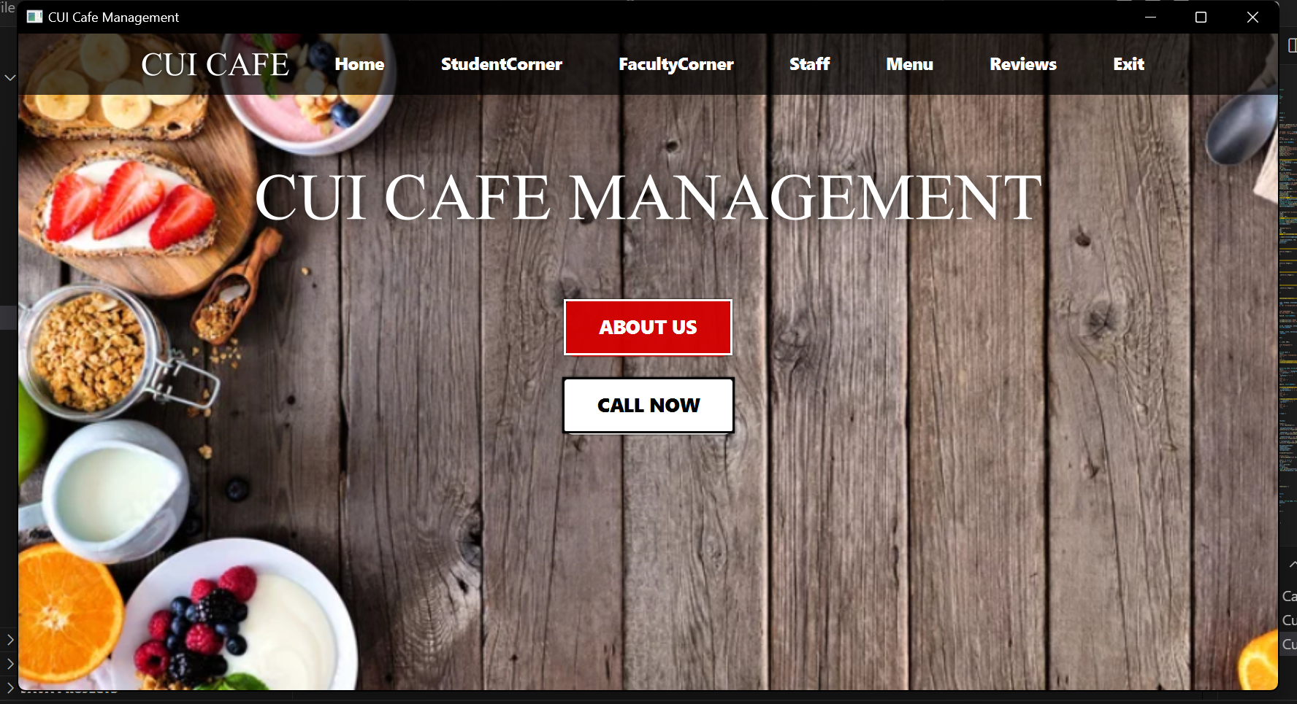

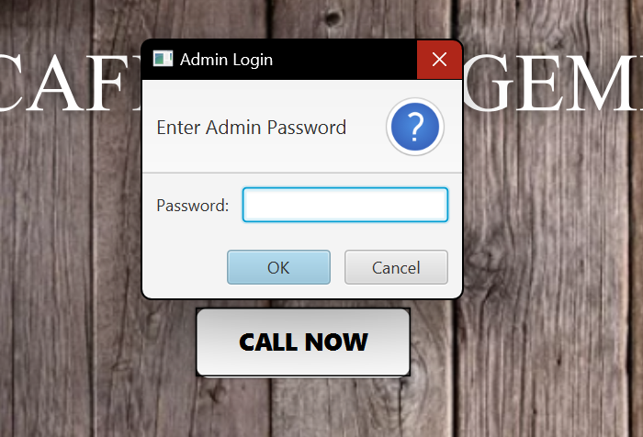

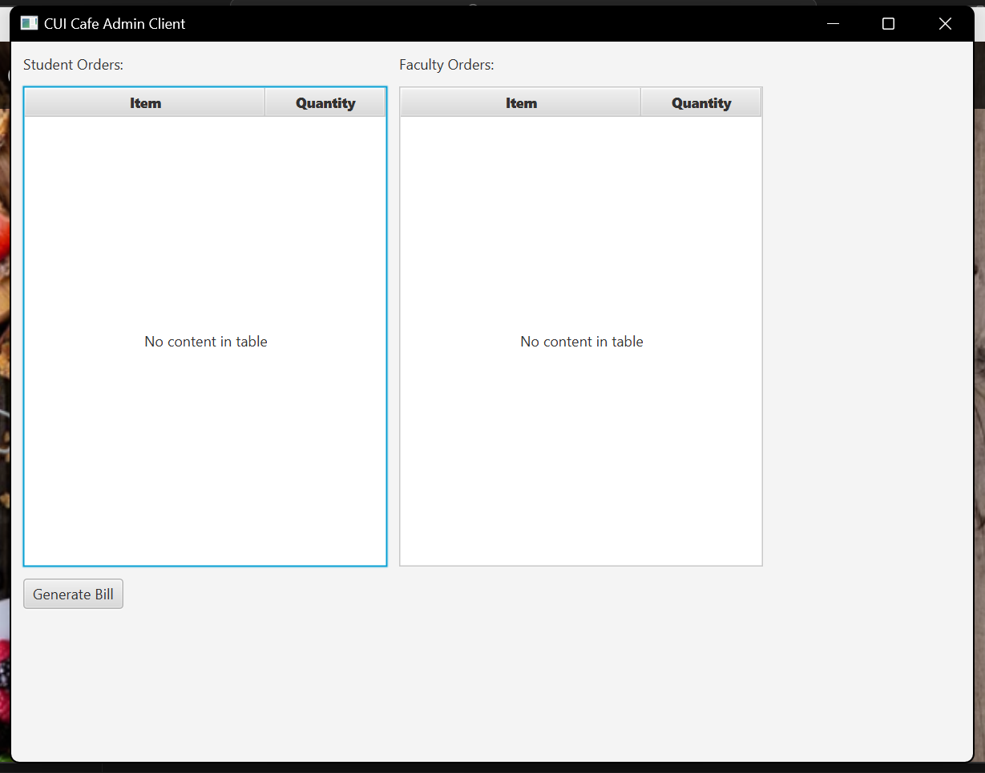

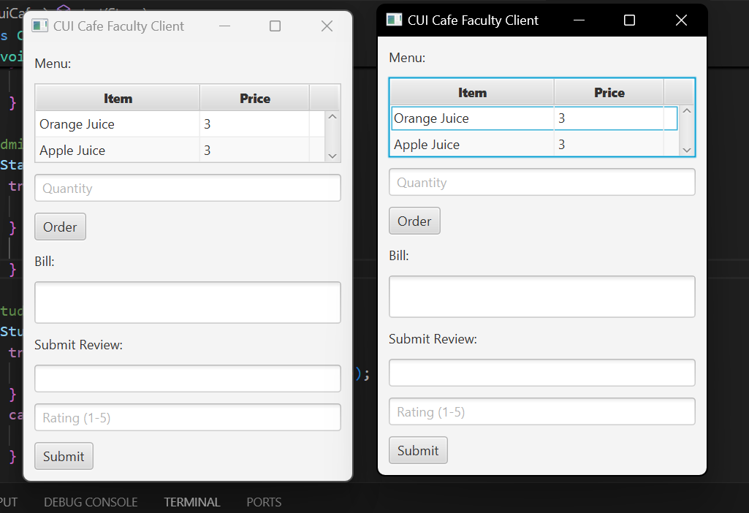

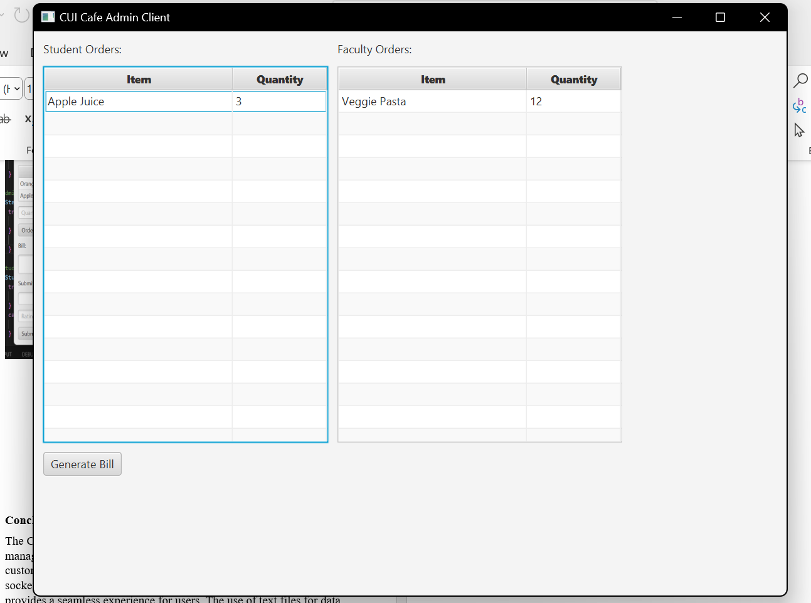

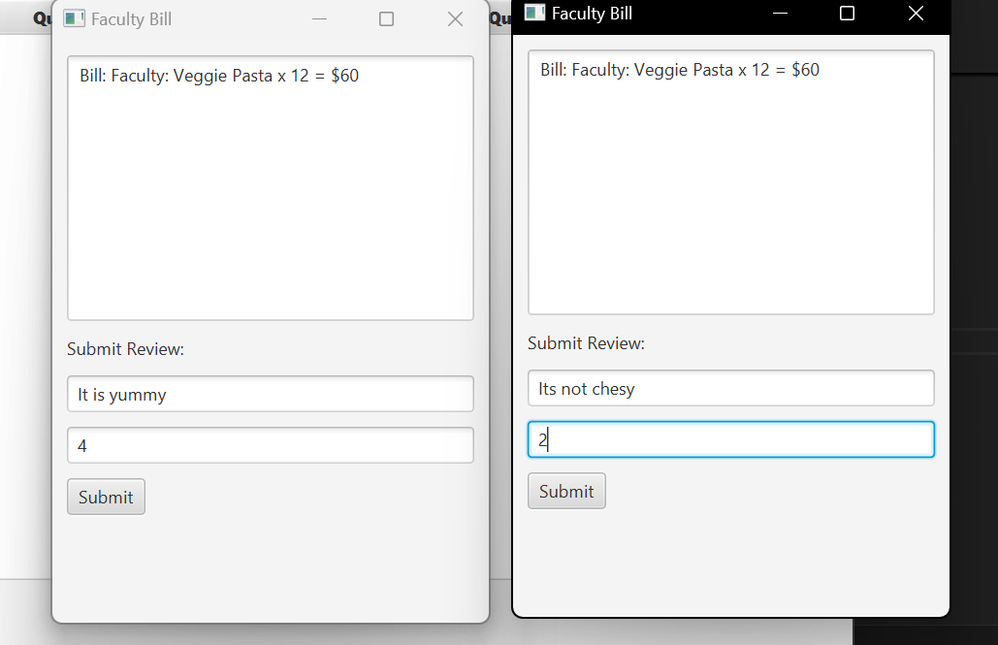

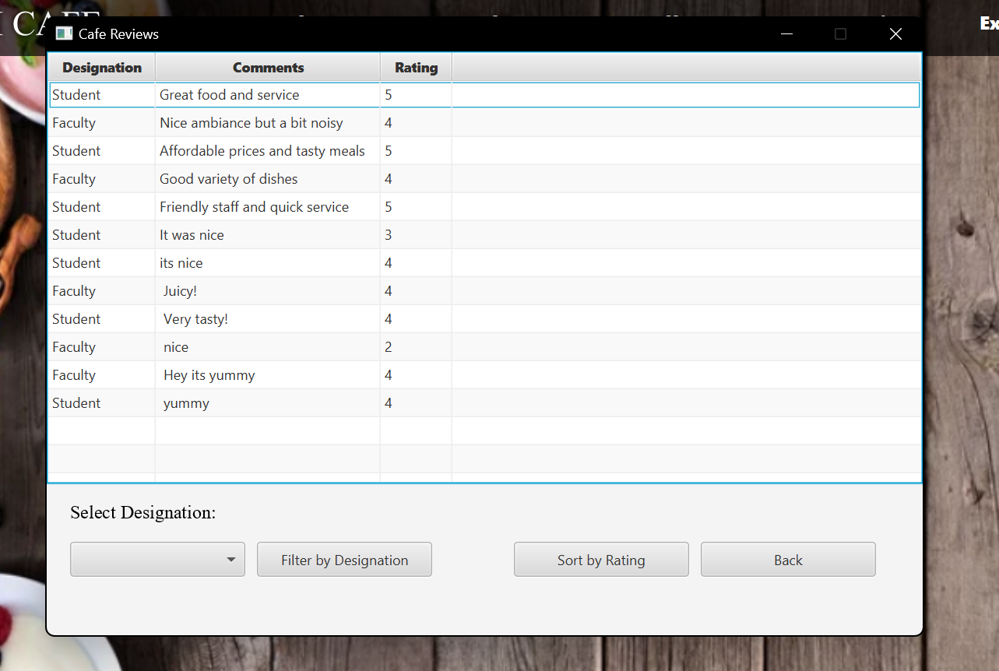

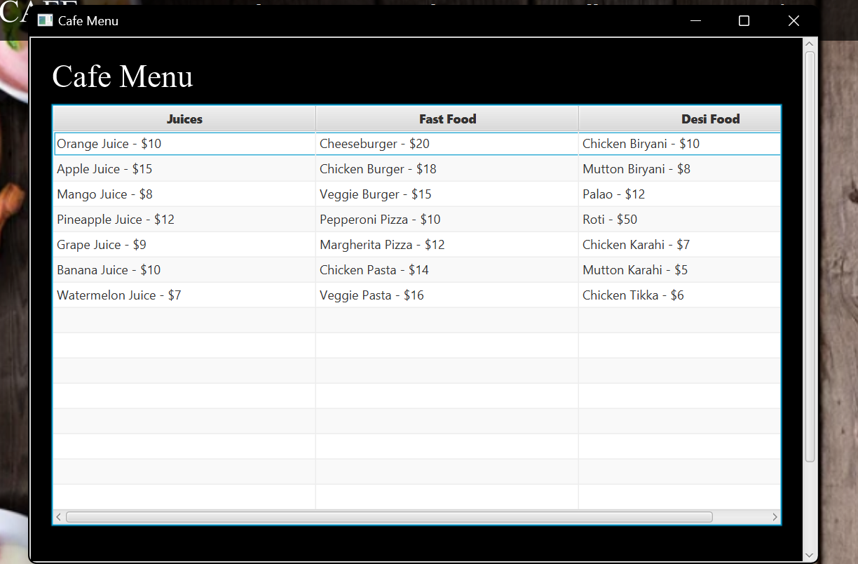

**Conclusion**

The CUI Cafe Management System is a comprehensive solution for managing cafe operations, allowing for efficient order processing and customer feedback. By utilizing JavaFX for the user interface and socket programming for client-server communication, the system provides a seamless experience for users. The use of text files for data storage ensures that the application remains lightweight and easy to manage.